

|  |
| --- |
| 3-4 BANNER (SIZE___) |
|  |
| SIZE: 2847 x 1001 - completed - Done |
|  |
|  |
|  |
|  |
|  |
|  |
|  |



Size: 647 x 970



Size: 1367 x 507-Done (Video + Banner)

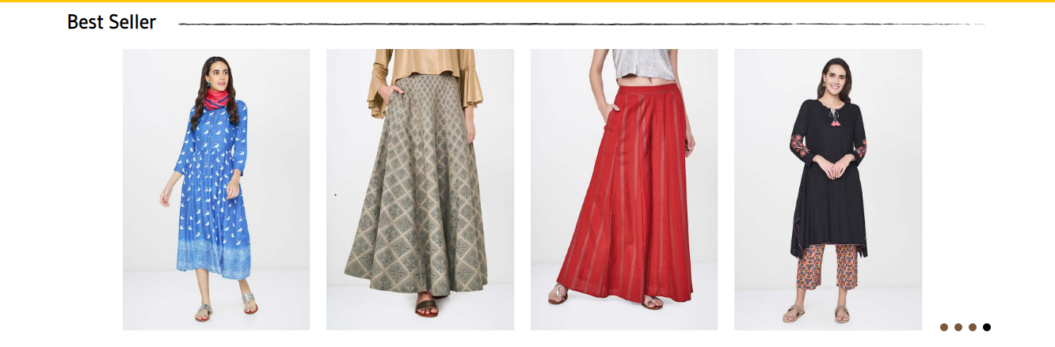

Size: 632 x 946



Size: 1367 x 507-Done



Size: 918 x 349 - Done

**Bottoms Banner**

**CUSTOMER TESTIMONIALS**





**Done**

